Business Requirement Document

V2.0

Project Name

RECONNECT DEVELOPMENT PORTAL

Change Log :

VERSION | DATE | DESCRIPTION | MODIFIED BY
V1.0 | 22/08/2017 | Initial draft of Reconnect Business Requirement Document | Swapnali Varak
V2.0 | 30/01/2018 | Final of Business Requirement Document | Nandkumar Patil

Contents

A. INTRODUCTION & SCOPE 3
B. EXPECTED BUSINESS BENEFIT 4
C. DETAILED BUSINESS REQUIREMENTS (Process & Wireframes) 4
C.1 USER INTERFACE REQUIREMENTS 13
D. BUSINESS SPONSOR / BUSINESS PROJECT MANAGER / STAKEHOLDERS 14
E. ANNEXURE 14

INTRODUCTION & SCOPE
About RECONNECT Development Web Portal:
RECONNECT is a very popular private label brand of Reliance Industries Limited for electronic products. Before any product launch, product has to go through development as well as different levels of testing which involved different departments too. Currently, this procedure is happening manually on paper. All records, forms and Documents are only on papers. RECONNECT Development Web Portal is nothing but the digitization of this manual process.
RECONNECT Web Portal brings all development, testing & their details including product related data, documents under one roof. This helps to track progress of development and testing of electronic product before it goes live.

The overall scope of Reconnect web portal is around the following activities:
- New Request creation for NPD and start development for the same
- Start Evaluation for new product
- Compliances check for new product
- Production go ahead through controlled documents
- Re-open already closed product for bug fixing
- History of closed projects & Documents
- Generate closed project report on yearly basis
Phase I covers all activities mentioned above. These Activities have been selected basis the immediate need and requirement of the business users.
This document describes the business requirement of the RECONNECT Development Web Portal for Phase I. The specifications are derived from the user needs. To describe the functionality involved, a wireframe is used. The Intention here is to define portal specifications that describe all possible requirements in the project.

EXPECTED BUSINESS BENEFIT
- This portal will help user to meet the delivery time line of the product. Especially into seasonal sell & bid day sell which results in numerous benefit to the users of product launch lifecycle.
- This project will help to reduce development time line, reduce unwanted email communication, correct and control document control for easy asses for repeat orders,
- It will help in real time project monitoring to meet delivery time.

DETAILED BUSINESS REQUIREMENTS (Process & Wireframes)
The Process of RECONNECT Development Web Portal is

Login & General
- As Reconnect portal will be developed on SharePoint technology, login is single-Sign-On and based on Domain credentials.
- Portal will be used on intranet.
- If Char limit not fitted in Table cell / Request form / Remark / Comments then, unfitted data should hidden & get displayed when hover on it mouse.

Top Menu Bar
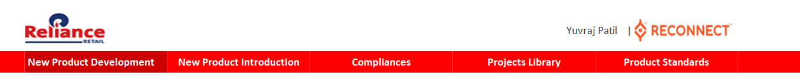
This screenshot is for reference purpose only.
Menu Bar | Fixed Top Menu type (Not scrolling with pages) | Should be on Every page of portal
Left side Top Logo | Reliance Retail logo as shown in screenshot
Right Side logo | RECONNECT Logo as shown in screenshot
User Name | Near to RECONNECT logo
New Product Development | Click : Go to New Product development dashboard
New Product Introduction | Click : Go to New Product Introduction dashboard
Compliance | Click : Go to compliance dashboard
Projects Library | Click : Go to Project Library page
Product standards | Click : Go to Product standards page

New Product Development: Dashboard
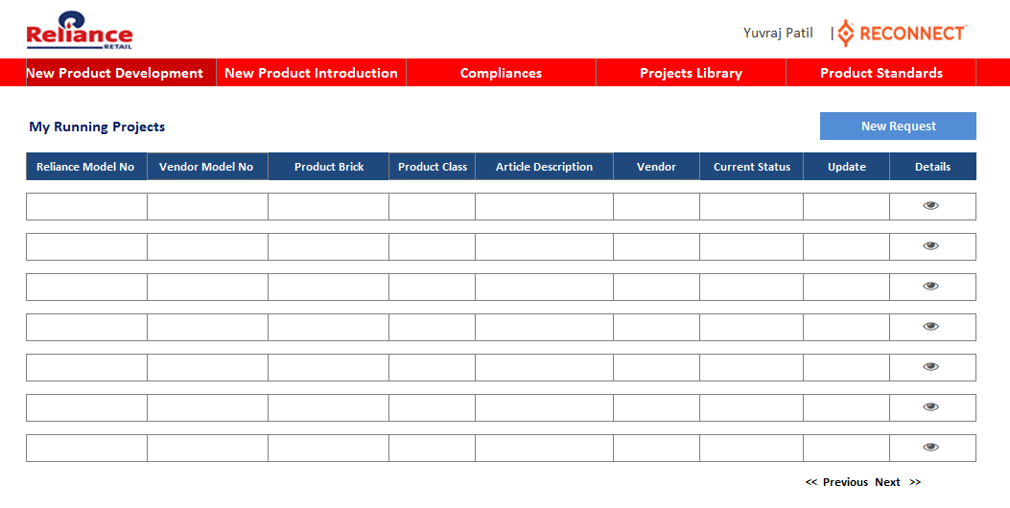

My Running Projects | Req: Running Projects or New Request under Draft should displayed | Req: 7* Projects should displayed on screen. No scrolling allowed *Depend upon page & font | Req: If projects are more than 7, Next & Previous icon should appear at Bottom. | Req: If projects are less than 7, Next & Previous icon should Not appear at Bottom.
New Request | Click : Go To New Request Page
Reliance Model No | Auto Data : From New Request Project Details
Vendor Model No
Product brick
Product class
Article Description
Vendor
Current status | Auto Data : New Request status should displayed by Draft/ Submitted/ Running | Draft : If New Request form is partly filled by user but not submitted | Submitted : Once user submit the New Request | Running : Once NPI person Check & mention comments against provided details by NPD
Update | Req: If NPI put comments against submitted document then Update should appear | Auto Data : Project update should displayed by Green , Red color | Green : No any update | Red : update are there & Need action
Details | Click : Go to Submitted New Request Page

NPD: New Request: Project details

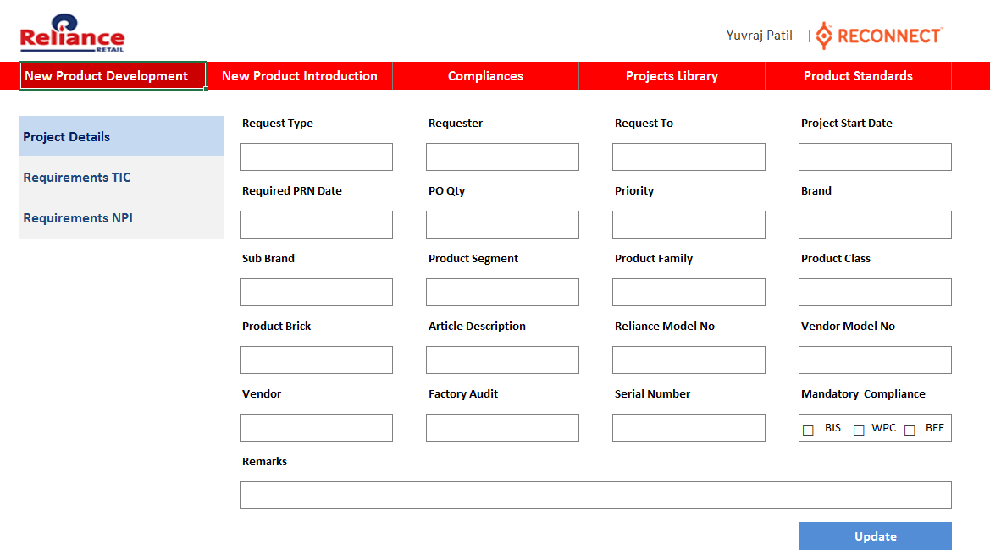
Request Type | Input Data : By default It should “ New Product Evaluation”
Requester | Input Data : By default it should login person
Request To | Input Data : selected user should be from Annexure 1 only
Project start Date | Input Data: Choose: calendar view to choose dates. 10/10/2018 & Numeric Format , 10 Char limit
Required PRN Date
PO Qty | Input Data : Numeric Format , 10 Char limit
Priority | Input Data : Drop down : Low , Mid , High
Brand | Input Data : Alphanumeric Format , 20 Char limit
Sub Brand | Input Data : Alphanumeric Format , 20 Char limit
Product segment | Input Data : Drop down : As per Annexure 2
Product Family | Input Data : Drop down : As per Annexure 2
Product class | Input Data : Drop down : As per Annexure 2
Product Brick | Input Data : Drop down : As per Annexure 2
Article Description | Input Data : Alphanumeric Format 50 Char limit
Reliance Model No | Input Data : Alphanumeric Format , 20 Char limit
Vendor Model No | Input Data : Alphanumeric Format , 20 Char limit
Vendor | Input Data : Alphanumeric Format 50 Char limit
Factory Audit | Input Data : Drop down : Done , To be Done
Serial Number | Input Data : Drop down : Applicable , Not Applicable
Mandatory Compliance | Input Data :Tick : BIS , BEE , WPC
Remark | Input Data : Alphanumeric Format 100 Char limit
Update | Click : Save all Filled data by user
Project Details | Click : Go to New current draft Request Project Details
Requirements TIC | Click : Go to New current draft Request Requirements TIC
Requirements NPI | Click : Go to New current draft Request Requirements NPI

NPD: New Request: Requirements TIC
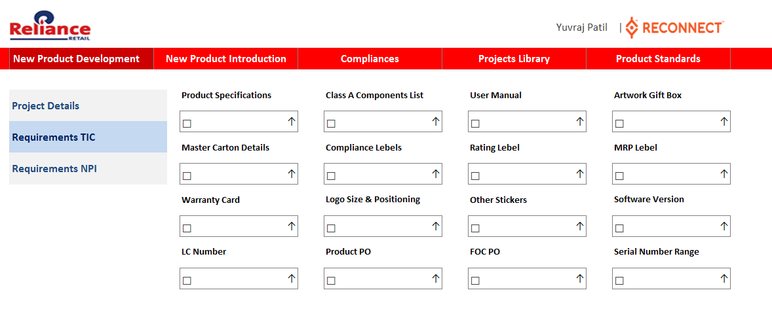
□ | No Write access to NPD | Once mouse pointer hover the comment box , NPD can see entire comment
Comments Box | No Write access to NPD
↑ | Upload Data: File upload pop up. Single File upload | Req: If Check Box is Approved by NPI by tick in adjacent check box then then NPD upload should disable. Only he can download
X | Delete Data : To update file , First file need to delete | Req: If Check Box is Approved by NPI by tick in adjacent check box then then NPD upload should disable. Only he can download
Project Details | Click : Go to New current draft Request Project Details
Requirements TIC | Click : Go to New current draft Request Requirements TIC
Requirements NPI | Click : Go to New current draft Request Requirements NPI

NPD: New Request: Requirements NPI
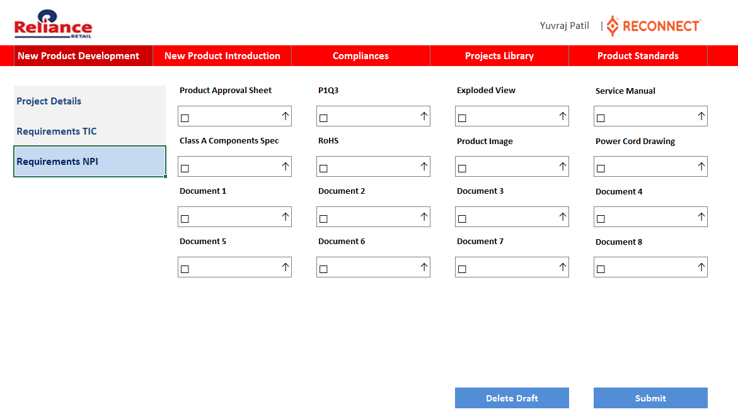
□ | No Write access to NPD | Once mouse pointer hover the comment box , NPD can see entire comment
Comments Box | No Write access to NPD
↑ | Upload Data: File upload pop up. Single file upload. | Req: If Check Box is Approved by NPI by tick in adjacent check box then then NPD upload should disable. Only he can download
X | Delete Data : To update file , First file need to delete | Req: If Check Box is Approved by NPI by tick in adjacent check box then then NPD upload should disable. Only he can download
Project Details | Click : Go to New current draft Request Project Details
Requirements TIC | Click : Go to New current draft Request Requirements TIC
Requirements NPI | Click : Go to New current draft Request Requirements NPI
Submit | Click: Request will submit to NPI & Compliance (Selected compliances).
Delete Draft | Click : Drafted New Request will delete

New Product Introduction: Dashboard
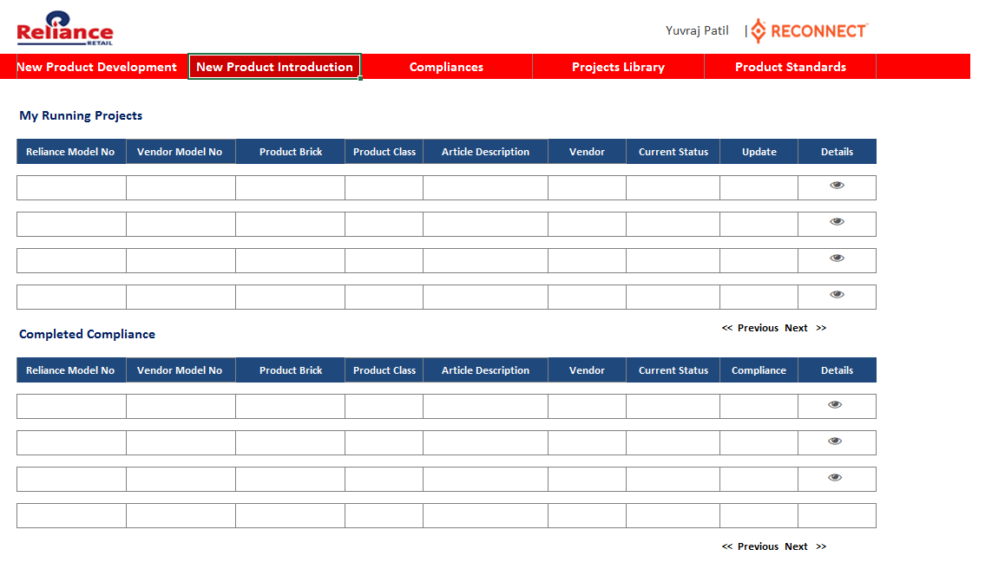
My Running Projects | Req: Running Projects should displayed | Req: 7* Projects should displayed on screen. No scrolling allowed *Depend upon page & font | Req: If projects are more than 7, Next & Previous icon should appear at Bottom. | Req: If projects are less than 7, Next & Previous icon should Not appear at Bottom.
Reliance Model No | Auto Data : From submitted Request by NPD Project Details
Vendor Model No
Product brick
Product class
Article Description
Vendor
Current status | Auto Data: NPI status should displayed by On Time / Delayed. This Status is from NPI Project PRN Release End delay. |  | On Time: This Status is from NPI Project PRN Release End delay. If End delay is zero or less than zero then status is ON Time | Delayed: This Status is from NPI Project PRN Release End delay. If End delay is more than one then Status is Delayed
Update | Req: If NPD upload any document or then Update should appear | Auto Data : update should displayed by Green , Red color | Green : No any update | Red : update are there & Need action
Details | Click : Go to New Product Introduction Request Page Product details page

Completed Compliance | Req: Running Projects only Completed compliance status should displayed | Req: 5* Projects should displayed on screen. No scrolling allowed *Depend upon page & font | Req: If projects are more than 5, Next & Previous icon should appear at Bottom. | Req: If projects are less than 5, Next & Previous icon should Not appear at Bottom.
Reliance Model No | Auto Data : From submitted Request by NPD Project Details
Vendor Model No
Product brick
Product class
Article Description
Vendor
Current status | Auto Data: Compliance status should displayed by On Time / Delayed. This Status is from Compliance Project Final certification End delay. |  | On Time: This Status is from Compliance Project Final certification End delay. If End delay is zero or less than zero then status is ON Time | Delayed: This Status is from Compliance Project Final certification End delay. If End delay is more than one then status is Delayed
Compliance | Auto Data: Compliance name should displayed “BEE”, “BIS”, “WPC”.
Details | Click : Go to respective compliance Pages

NPI: Details: Project Details
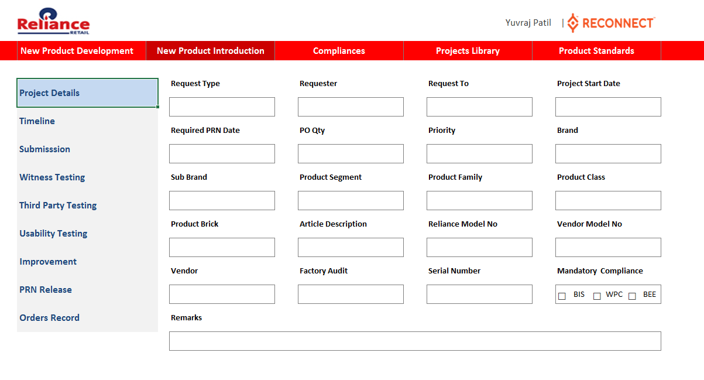
Request Type | Auto Data : From submitted Request by NPD Project Details
Requester | Auto Data : From submitted Request by NPD Project Details
Request To | Auto Data : From submitted Request by NPD Project Details
Project start Date | Auto Data : From submitted Request by NPD Project Details
Required PRN Date | Auto Data : From submitted Request by NPD Project Details
PO Qty | Auto Data : From submitted Request by NPD Project Details
Priority | Auto Data : From submitted Request by NPD Project Details
Brand | Auto Data : From submitted Request by NPD Project Details
Sub Brand | Auto Data : From submitted Request by NPD Project Details
Product segment | Auto Data : From submitted Request by NPD Project Details
Product Family | Auto Data : From submitted Request by NPD Project Details
Product class | Auto Data : From submitted Request by NPD Project Details
Product Brick | Auto Data : From submitted Request by NPD Project Details
Article Description | Auto Data : From submitted Request by NPD Project Details
Reliance Model No | Auto Data : From submitted Request by NPD Project Details
Vendor Model No | Auto Data : From submitted Request by NPD Project Details
Vendor | Auto Data : From submitted Request by NPD Project Details
Factory Audit | Auto Data : From submitted Request by NPD Project Details
Serial Number | Auto Data : From submitted Request by NPD Project Details
Mandatory Compliance | Auto Data : From submitted Request by NPD Project Details
Remark | Auto Data : From submitted Request by NPD Project Details
Update | Auto Data : From submitted Request by NPD Project Details
Project Details | Click : Go to current NPI Details Project Details
Timeline | Click : Go to current NPI Details Timeline
Submission | Click : Go to current NPI Details Submission
Witness Testing | Click : Go to current NPI Details Witness Testing
Third Party Testing | Click : Go to current NPI Details Third Party Testing
Usability Testing | Click : Go to current NPI Details Usability Testing
Improvement | Click : Go to current NPI Details Improvement
PRN Release | Click : Go to current NPI Details PRN Release
Orders Record | Click : Go to current NPI Details Orders Record

NPI: Details: Timeline
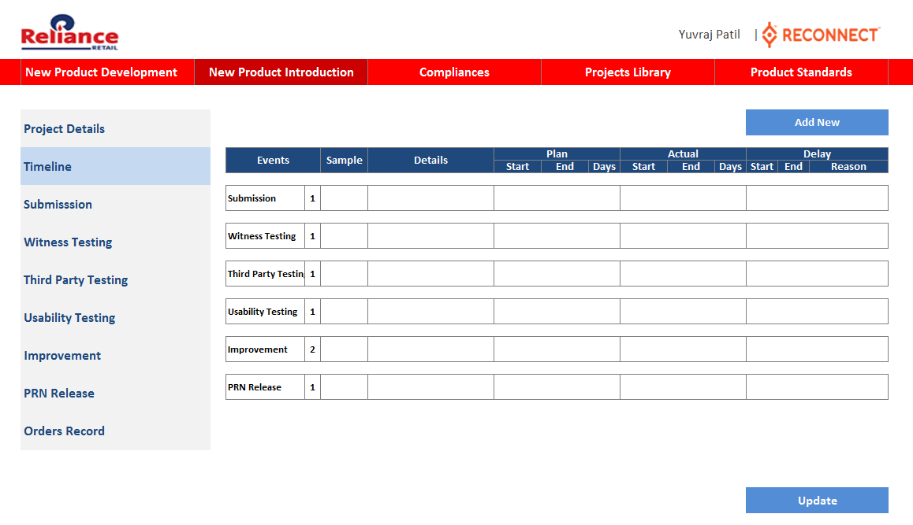
Add New | Click: Add New will add new event among WT, TT, UT, Impr. | Req: If user added new event then same should be added in events respective pages. | Req: No need to add New event for submission & PRN Release. | Req: During adding event, events name is fixed but user can add event numbers.
Events | Req: By default all events (Submission, WT, TT, UT, Impr. PRN) are mandatory in every timeline. User may add events as mentioned in Add new but cannot delete by default events.
Sample | Input Data : Alphanumeric Format 5 Char limit
Details | Input Data : Alphanumeric Format 50 Char limit
Plan Start , End | Input Data: Choose: calendar view to choose dates. 10/10/2018 & Numeric Format , 10 Char limit
Plan Days | Auto Data: (Plan End – Plan Start), Values in number format.
Actual Start | Input Data: Choose: calendar view to choose dates. 10/10/2018 & Numeric Format , 10 Char limit
Actual End | Auto & Input Data: Once user mentioned start date, Automatically today’s date should come till user manually select date.
Actual Days | Auto Data: (Actual End – Actual Start), Values in number format.
Delay Start | Auto Data: (Plan start – Actual Start), Values in number format
Delay End | Auto Data: (Plan End – Actual End ), Values in number format
Reasons | Input Data : Alphanumeric Format 100 Char limit
Update | Click : Save all new updates
Project Details | Click : Go to current NPI Details Project Details
Timeline | Click : Go to current NPI Details Timeline
Submission | Click : Go to current NPI Details Submission
Witness Testing | Click : Go to current NPI Details Witness Testing
Third Party Testing | Click : Go to current NPI Details Third Party Testing
Usability Testing | Click : Go to current NPI Details Usability Testing
Improvement | Click : Go to current NPI Details Improvement
PRN Release | Click : Go to current NPI Details PRN Release
Orders Record | Click : Go to current NPI Details Orders Record

NPI: Details: submission
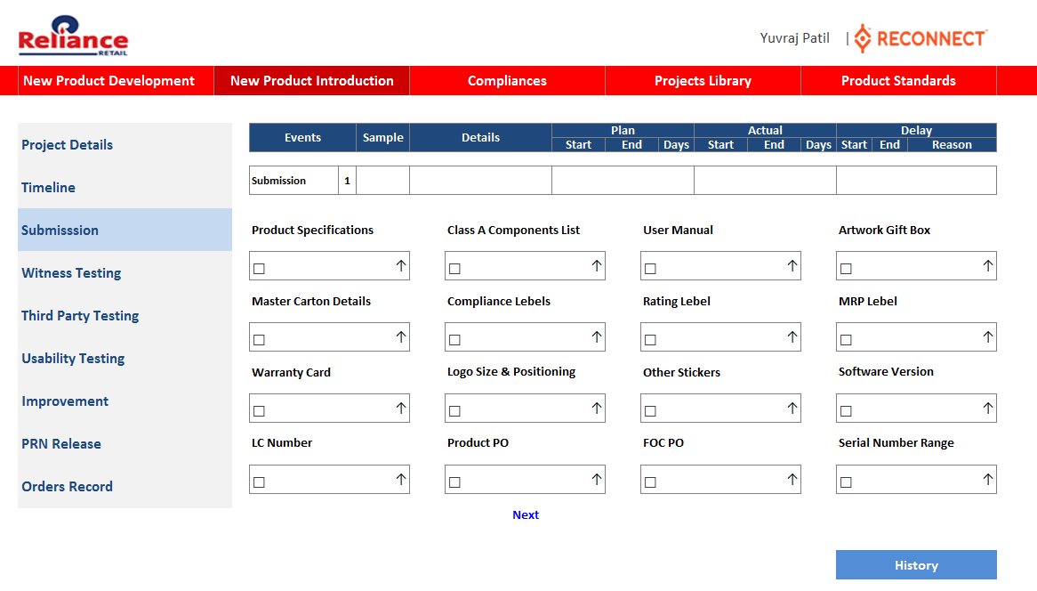
Timeline Table | Auto Data: If user added new event in Timeline page then same should be added in events respective pages.
Documents uploads : □ | Input Data : Check box | Req: If Check Box is Approved by NPI by tick in adjacent check box then then NPD upload should disable. Only he can download
Documents uploads : ↓ | Download Data : Uploaded documents will download
Documents uploads : Comments | Input Data : Alphanumeric Format 100 Char limit
Documents upload : Save | Click : Save the comments
Next | Click : Go to current NPI Details Submission next page
History | Click : Go to current NPI Details Submission History page
Project Details | Click : Go to current NPI Details Project Details
Timeline | Click : Go to current NPI Details Timeline
Submission | Click : Go to current NPI Details Submission
Witness Testing | Click : Go to current NPI Details Witness Testing
Third Party Testing | Click : Go to current NPI Details Third Party Testing
Usability Testing | Click : Go to current NPI Details Usability Testing
Improvement | Click : Go to current NPI Details Improvement
PRN Release | Click : Go to current NPI Details PRN Release
Orders Record | Click : Go to current NPI Details Orders Record

NPI: Details: Witness Testing
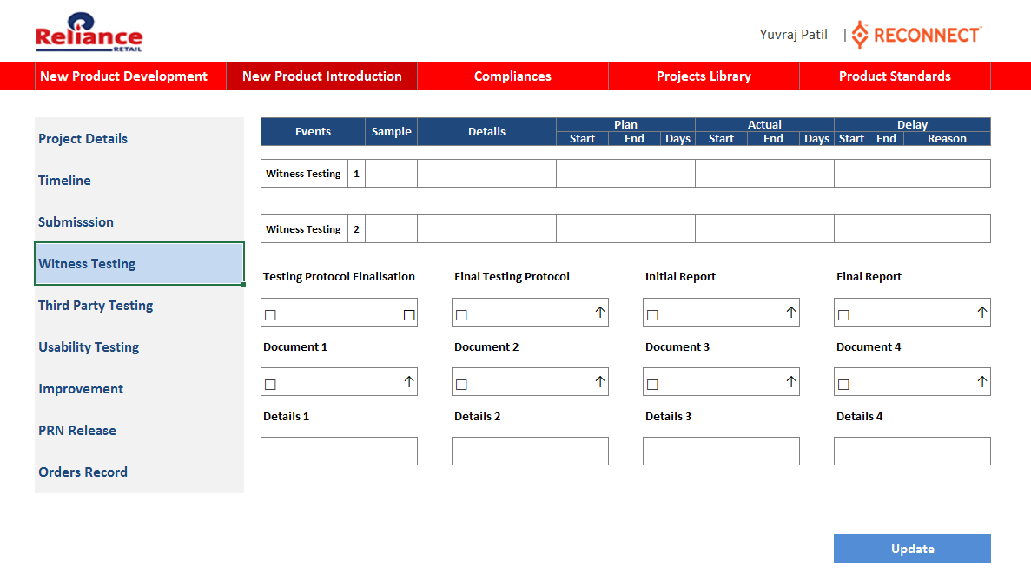
Timeline Table | Auto Data: If user added new event in Timeline page then same should be added in events respective pages.
Documents uploads : □ Check Box 1 | Input Data : Check box : Check Box 1 tick ON + click on update means uploaded documents / Check box 2 tick by NPI is freezed & need to store | Req: If NPI user need to update freezed documents / check Box 2 then he has to untick Check Box 1.
□ Check Box 2 | Input Data :Tick/ Untick : Process is done / Not Done
Documents uploads : ↑ | Upload Data: File upload pop up. Single File upload
Details | Input Data : Alphanumeric Format 100 Char limit
Documents uploads : Comments | Input Data : Alphanumeric Format 100 Char limit
Documents upload : Save | Click : Save the comments
Update | Click : Save the uploaded documents
Project Details | Click : Go to current NPI Details Project Details
Timeline | Click : Go to current NPI Details Timeline
Submission | Click : Go to current NPI Details Submission
Witness Testing | Click : Go to current NPI Details Witness Testing
Third Party Testing | Click : Go to current NPI Details Third Party Testing
Usability Testing | Click : Go to current NPI Details Usability Testing
Improvement | Click : Go to current NPI Details Improvement
PRN Release | Click : Go to current NPI Details PRN Release
Orders Record | Click : Go to current NPI Details Orders Record

NPI: Details: Third Party Testing

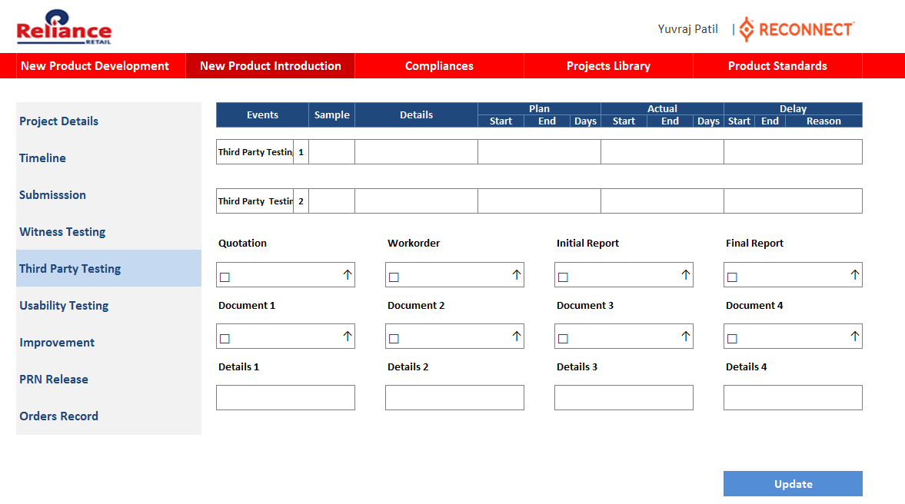
Timeline Table | Auto Data: If user added new event in Timeline page then same should be added in events respective pages.
Documents uploads : □ Check Box 1 | Input Data : Check box : Check Box 1 tick ON + click on update means uploaded documents / Check box 2 tick by NPI is freezed & need to store | Req: If NPI user need to update freezed documents / check Box 2 then he has to untick Check Box 1.
□ Check Box 2 | Input Data :Tick/ Untick : Process is done / Not Done
Documents uploads : ↑ | Upload Data: File upload pop up. Single File upload
Details | Input Data : Alphanumeric Format 100 Char limit
Documents uploads : Comments | Input Data : Alphanumeric Format 100 Char limit
Documents upload : Save | Click : Save the comments
Update | Click : Save the uploaded documents
Project Details | Click : Go to current NPI Details Project Details
Timeline | Click : Go to current NPI Details Timeline
Submission | Click : Go to current NPI Details Submission
Witness Testing | Click : Go to current NPI Details Witness Testing
Third Party Testing | Click : Go to current NPI Details Third Party Testing
Usability Testing | Click : Go to current NPI Details Usability Testing
Improvement | Click : Go to current NPI Details Improvement
PRN Release | Click : Go to current NPI Details PRN Release
Orders Record | Click : Go to current NPI Details Orders Record

NPI: Details: Usability Testing

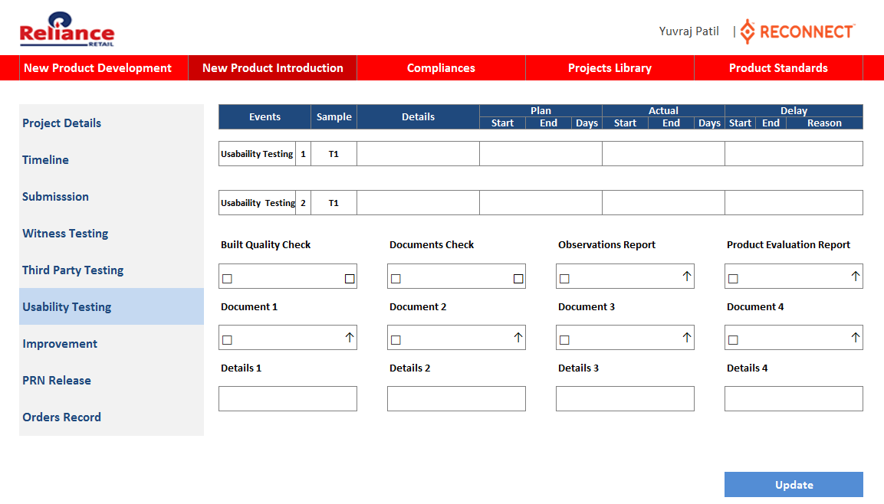
Timeline Table | Auto Data: If user added new event in Timeline page then same should be added in events respective pages.
Documents uploads : □ Check Box 1 | Input Data : Check box : Check Box 1 tick ON + click on update means uploaded documents / Check box 2 tick by NPI is freezed & need to store | Req: If NPI user need to update freezed documents / check Box 2 then he has to untick Check Box 1.
□ Check Box 2 | Input Data :Tick/ Untick : Process is done / Not Done
Documents uploads : ↑ | Upload Data: File upload pop up. Single File upload
Details | Input Data : Alphanumeric Format 100 Char limit
Documents uploads : Comments | Input Data : Alphanumeric Format 100 Char limit
Documents upload : Save | Click : Save the comments
Update | Click : Save the uploaded documents
Project Details | Click : Go to current NPI Details Project Details
Timeline | Click : Go to current NPI Details Timeline
Submission | Click : Go to current NPI Details Submission
Witness Testing | Click : Go to current NPI Details Witness Testing
Third Party Testing | Click : Go to current NPI Details Third Party Testing
Usability Testing | Click : Go to current NPI Details Usability Testing
Improvement | Click : Go to current NPI Details Improvement
PRN Release | Click : Go to current NPI Details PRN Release
Orders Record | Click : Go to current NPI Details Orders Record

NPI: Details: Improvements
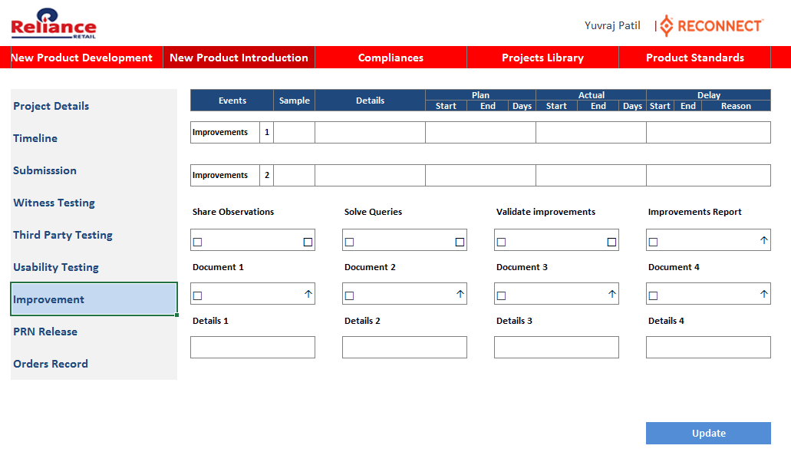
Timeline Table | Auto Data: If user added new event in Timeline page then same should be added in events respective pages.
Documents uploads : □ Check Box 1 | Input Data : Check box : Check Box 1 tick ON + click on update means uploaded documents / Check box 2 tick by NPI is freezed & need to store | Req: If NPI user need to update freezed documents / check Box 2 then he has to untick Check Box 1.
□ Check Box 2 | Input Data :Tick/ Untick : Process is done / Not Done
Documents uploads : ↑ | Upload Data: File upload pop up. Single File upload
Details | Input Data : Alphanumeric Format 100 Char limit
Documents uploads : Comments | Input Data : Alphanumeric Format 100 Char limit
Documents upload : Save | Click : Save the comments
Update | Click : Save the uploaded documents
Project Details | Click : Go to current NPI Details Project Details
Timeline | Click : Go to current NPI Details Timeline
Submission | Click : Go to current NPI Details Submission
Witness Testing | Click : Go to current NPI Details Witness Testing
Third Party Testing | Click : Go to current NPI Details Third Party Testing
Usability Testing | Click : Go to current NPI Details Usability Testing
Improvement | Click : Go to current NPI Details Improvement
PRN Release | Click : Go to current NPI Details PRN Release
Orders Record | Click : Go to current NPI Details Orders Record

NPI: Details: PRN Release
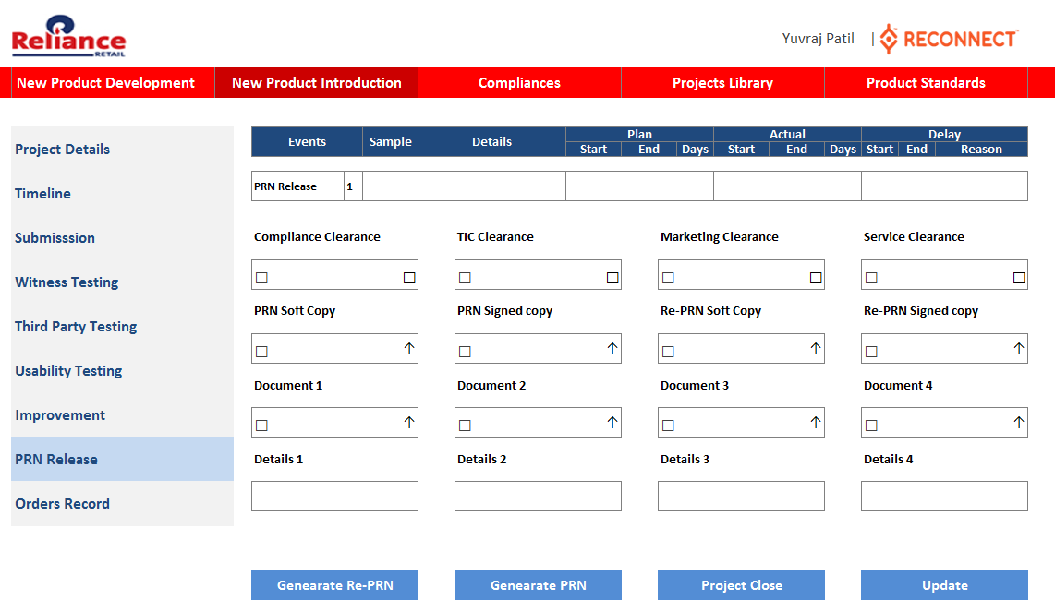
Timeline Table | Auto Data: If user added new event in Timeline page then same should be added in events respective pages.
Documents uploads : □ Check Box 1 | Input Data : Check box : Check Box 1 tick ON + click on update means uploaded documents / Check box 2 tick by NPI is freezed & need to store | Req: If NPI user need to update freezed documents / check Box 2 then he has to untick Check Box 1.
□ Check Box 2 | Input Data :Tick/ Untick : Process is done / Not Done
Documents uploads : ↑ | Upload Data: File upload pop up. Single File upload
Details | Input Data : Alphanumeric Format 100 Char limit
Documents uploads : Comments | Input Data : Alphanumeric Format 100 Char limit
Documents upload : Save | Click : Save the comments
Update | Click : Save the uploaded documents
Project Close | Click: Save entire project to library & Remove from NPI, NPD Dashboard But not from compliance dashboard. | Req: Project close is disable till NPI person upload PRN Signed copy for new orders & Re-PRN Signed copy for repeat orders document upload.
Generate PRN | Click : Go to PRN page & generate PRN
Generate Re-PRN | Click : Go to PRN page & generate Re-PRN
Project Details | Click : Go to current NPI Details Project Details
Timeline | Click : Go to current NPI Details Timeline
Submission | Click : Go to current NPI Details Submission
Witness Testing | Click : Go to current NPI Details Witness Testing
Third Party Testing | Click : Go to current NPI Details Third Party Testing
Usability Testing | Click : Go to current NPI Details Usability Testing
Improvement | Click : Go to current NPI Details Improvement
PRN Release | Click : Go to current NPI Details PRN Release
Orders Record | Click : Go to current NPI Details Orders Record

NPI: Details: Orders Record
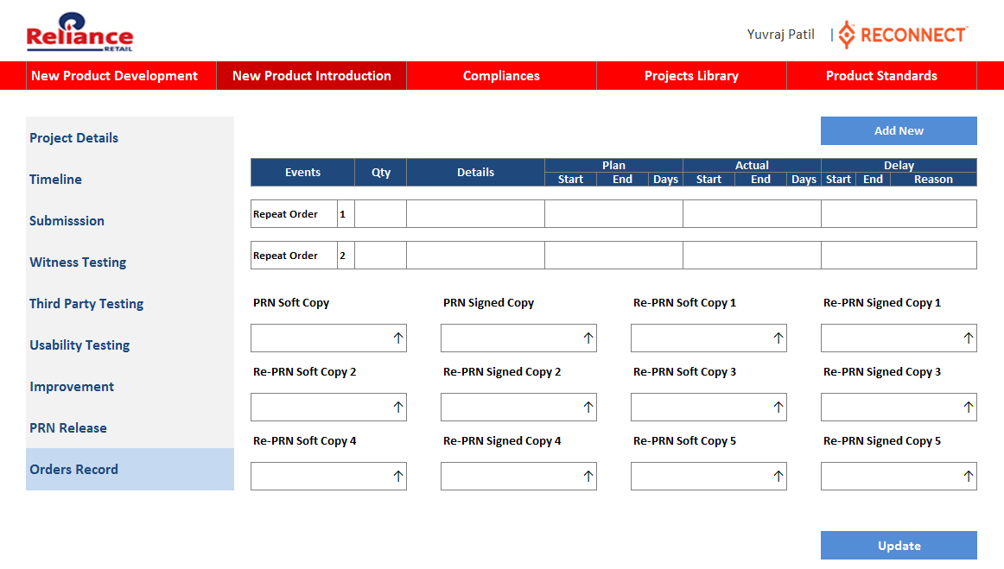
Add New | Click: Add single Row in Order Record page timeline table
Table : Events , Qty , Details, Reasons | Input Data: Alphanumeric Format 100 Char limit
Table: Plan Start , End | Input Data: Choose: calendar view to choose dates. 10/10/2018 & Numeric Format , 10 Char limit
Table: Plan Days | Auto Data: (Plan End – Plan Start), Values in number format.
Table: Actual Start | Input Data: Choose: calendar view to choose dates. 10/10/2018 & Numeric Format , 10 Char limit
Table: Actual End | Input Data: Choose: calendar view to choose dates. 10/10/2018 & Numeric Format , 10 Char limit
Table: Actual Days | Auto Data: (Actual End – Actual Start), Values in number format.
Table: Delay Start | Auto Data: (Plan start – Actual Start), Values in number format
Table: Delay End | Auto Data: (Plan End – Actual End ), Values in number format
Documents Download : ↓ | Auto download Data: Uploaded PRN & Re-PRN available for download.
Update | Click : Save the comments & data mentioned in Table
Project Details | Click : Go to current NPI Details Project Details
Timeline | Click : Go to current NPI Details Timeline
Submission | Click : Go to current NPI Details Submission
Witness Testing | Click : Go to current NPI Details Witness Testing
Third Party Testing | Click : Go to current NPI Details Third Party Testing
Usability Testing | Click : Go to current NPI Details Usability Testing
Improvement | Click : Go to current NPI Details Improvement
PRN Release | Click : Go to current NPI Details PRN Release
Orders Record | Click : Go to current NPI Details Orders Record

Compliance: Dashboard
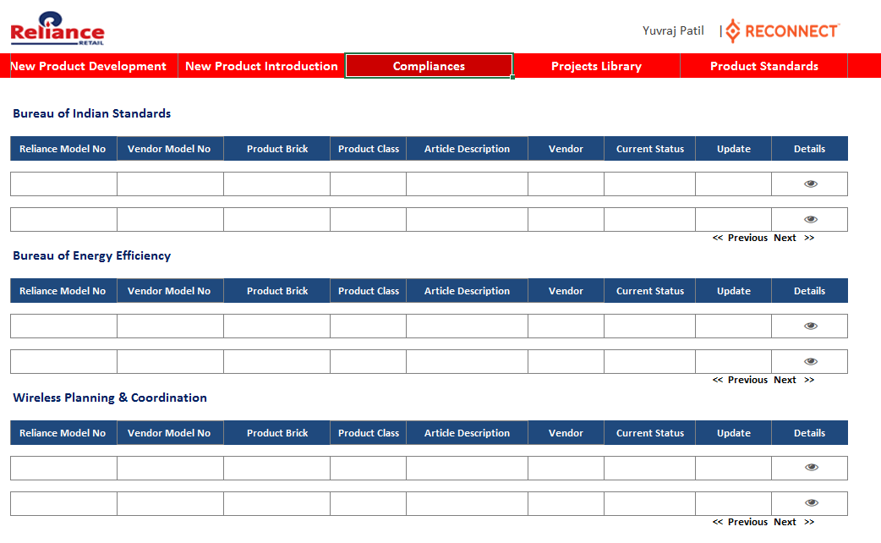
Bureau of Indian Standards | Req: If NPD new request →Mandatory compliance→ BIS is selected then once NPD submit the request then request should displayed. |  | Req: 5* Projects should displayed on screen. No scrolling allowed *Depend upon page & font | Req: If projects are more than 5, Next & Previous icon should appear at Bottom. |  | Req: If projects are less than 5, Next & Previous icon should Not appear at Bottom.
Bureau of Energy Efficiency | Req: If NPD new request →Mandatory compliance→ BEE is selected then once NPD submit the request then request should displayed. |  | Req: 5* Projects should displayed on screen. No scrolling allowed *Depend upon page & font | Req: If projects are more than 5, Next & Previous icon should appear at Bottom. |  | Req: If projects are less than 5, Next & Previous icon should Not appear at Bottom.
Wireless Planning & Coordination | Req: If NPD new request →Mandatory compliance→ WPC is selected then once NPD submit the request then request should displayed. |  | Req: 5* Projects should displayed on screen. No scrolling allowed *Depend upon page & font | Req: If projects are more than 5, Next & Previous icon should appear at Bottom. |  | Req: If projects are less than 5, Next & Previous icon should Not appear at Bottom.
Reliance Model No | Auto Data : From New Request Project Details
Vendor Model No
Product brick
Product class
Article Description
Vendor
Current status | Auto Data: Respective compliance status should displayed by On Time / Delayed. This Status is from respective compliance→Details→ Timeline→final certification End delay. |  |  |  | On Time: If End delay is zero or less than zero then status is ON Time |  | Delayed: If End delay is more than one then Status is Delayed
Update | Req: If Compliance upload any document or then Update should appear | Auto Data : update should displayed by Green , Red color |  |  | Green : No any update |  | Red : update are there & Need action
Details | Click : Go to respective compliance details

BIS: Details: Product Details
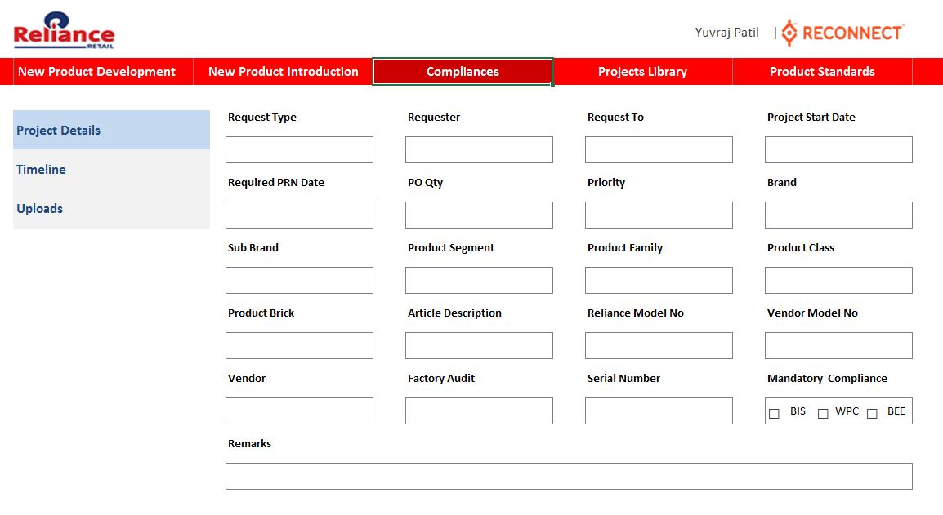
Request Type | Auto Data : From submitted Request by NPD Project Details
Requester | Auto Data : From submitted Request by NPD Project Details
Request To | Auto Data : From submitted Request by NPD Project Details
Project start Date | Auto Data : From submitted Request by NPD Project Details
Required PRN Date | Auto Data : From submitted Request by NPD Project Details
PO Qty | Auto Data : From submitted Request by NPD Project Details
Priority | Auto Data : From submitted Request by NPD Project Details
Brand | Auto Data : From submitted Request by NPD Project Details
Sub Brand | Auto Data : From submitted Request by NPD Project Details
Product segment | Auto Data : From submitted Request by NPD Project Details
Product Family | Auto Data : From submitted Request by NPD Project Details
Product class | Auto Data : From submitted Request by NPD Project Details
Product Brick | Auto Data : From submitted Request by NPD Project Details
Article Description | Auto Data : From submitted Request by NPD Project Details
Reliance Model No | Auto Data : From submitted Request by NPD Project Details
Vendor Model No | Auto Data : From submitted Request by NPD Project Details
Vendor | Auto Data : From submitted Request by NPD Project Details
Factory Audit | Auto Data : From submitted Request by NPD Project Details
Serial Number | Auto Data : From submitted Request by NPD Project Details
Mandatory Compliance | Auto Data : From submitted Request by NPD Project Details
Remark | Auto Data : From submitted Request by NPD Project Details
Update | Auto Data : From submitted Request by NPD Project Details
Project Details | Click : Go to current Compliance BIS Details
Timeline | Click : Go to current Compliance BIS Timeline
Uploads | Click : Go to current Compliance BIS Uploads

BIS: Details: Timeline
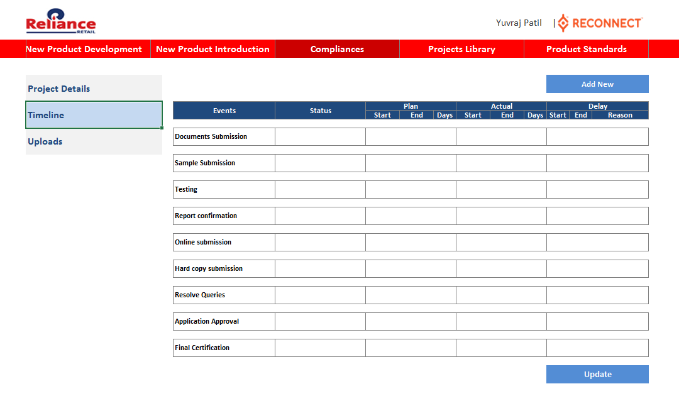
Add New | Click: Add single blank Row at bottom of timeline table
Events | Req: By default all events are mandatory in every timeline. User may add new Row for another events but cannot delete by default events. | Input Data : Alphanumeric Format 50 Char limit
Details | Input Data : Alphanumeric Format 100 Char limit
Plan Start , End | Input Data: Choose: calendar view to choose dates. 10/10/2018 & Numeric Format , 10 Char limit
Plan Days | Auto Data: (Plan End – Plan Start), Values in number format.
Actual Start | Input Data: Choose: calendar view to choose dates. 10/10/2018 & Numeric Format , 10 Char limit
Actual End | Auto & Input Data: Once user mentioned start date, Automatically today’s date should come till user manually select date.
Actual Days | Auto Data: (Actual End – Actual Start), Values in number format.
Delay Start | Auto Data: (Plan start – Actual Start), Values in number format
Delay End | Auto Data: (Plan End – Actual End ), Values in number format
Reasons | Input Data : Alphanumeric Format 100 Char limit
Update | Click : Save all new updates
Project Details | Click : Go to current Compliance BIS Details
Timeline | Click : Go to current Compliance BIS Timeline
Uploads | Click : Go to current Compliance BIS Uploads

BIS: Details: Uploads
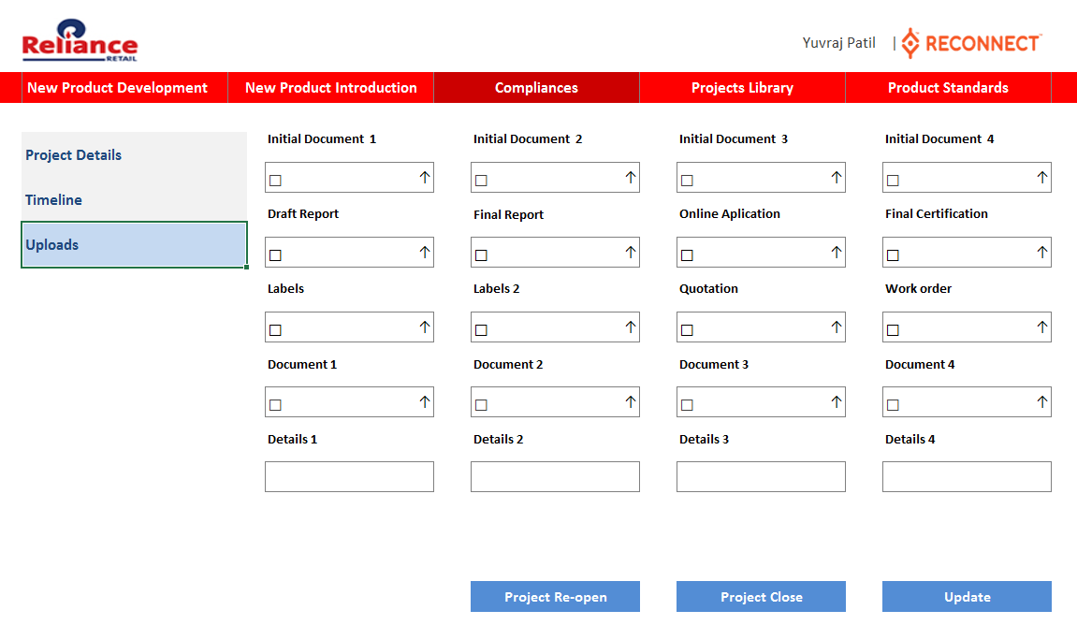
Documents uploads : □ | Input Data : Check box : Check Box tick ON + click on update means uploaded documents by compliance is freezed & need to store | Req: If compliance user need to update freezed documents then he has to untick Check Box.
Documents uploads : ↑ | Upload Data: File upload pop up. Zip File upload
Details | Input Data : Alphanumeric Format 100 Char limit
Documents uploads : Comments | Input Data : Alphanumeric Format 100 Char limit
Documents upload : Save | Click : Save the comments
Update | Click : Save the uploaded documents
Project Close | Click : Project request get removed from compliance dashboard , stored in library & same time get displayed in NPI dashboard completed compliance.
Project Re-Open | Click: Project will get displayed in Compliance dashboard.
Project Details | Click : Go to current Compliance BIS Details
Timeline | Click : Go to current Compliance BIS Timeline
Uploads | Click : Go to current Compliance BIS Uploads

BEE: Details: Product Details
Request Type | Auto Data : From submitted Request by NPD Project Details
Requester | Auto Data : From submitted Request by NPD Project Details
Request To | Auto Data : From submitted Request by NPD Project Details
Project start Date | Auto Data : From submitted Request by NPD Project Details
Required PRN Date | Auto Data : From submitted Request by NPD Project Details
PO Qty | Auto Data : From submitted Request by NPD Project Details
Priority | Auto Data : From submitted Request by NPD Project Details
Brand | Auto Data : From submitted Request by NPD Project Details
Sub Brand | Auto Data : From submitted Request by NPD Project Details
Product segment | Auto Data : From submitted Request by NPD Project Details
Product Family | Auto Data : From submitted Request by NPD Project Details
Product class | Auto Data : From submitted Request by NPD Project Details
Product Brick | Auto Data : From submitted Request by NPD Project Details
Article Description | Auto Data : From submitted Request by NPD Project Details
Reliance Model No | Auto Data : From submitted Request by NPD Project Details
Vendor Model No | Auto Data : From submitted Request by NPD Project Details
Vendor | Auto Data : From submitted Request by NPD Project Details
Factory Audit | Auto Data : From submitted Request by NPD Project Details
Serial Number | Auto Data : From submitted Request by NPD Project Details
Mandatory Compliance | Auto Data : From submitted Request by NPD Project Details
Remark | Auto Data : From submitted Request by NPD Project Details
Update | Auto Data : From submitted Request by NPD Project Details
Project Details | Click : Go to current Compliance BEE Details
Timeline | Click : Go to current Compliance BEE Timeline
Uploads | Click : Go to current Compliance BEE Uploads

BEE: Details: Timeline
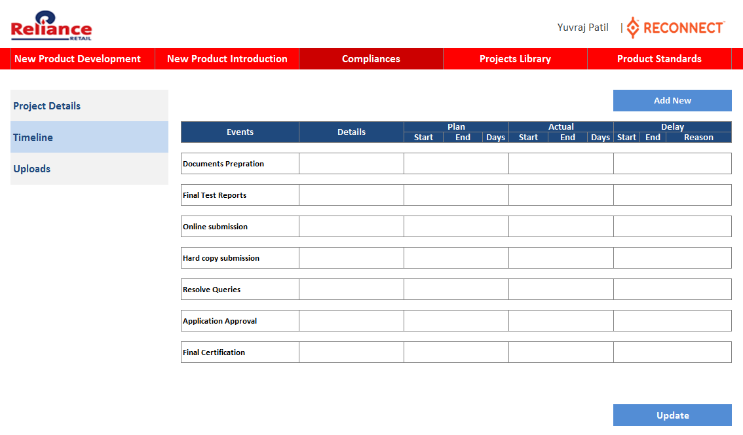
Add New | Click: Add single blank Row at bottom of timeline table
Events | Req: By default all events are mandatory in every timeline. User may add new Row for another events but cannot delete by default events. | Input Data : Alphanumeric Format 50 Char limit
Details | Input Data : Alphanumeric Format 100 Char limit
Plan Start , End | Input Data: Choose: calendar view to choose dates. 10/10/2018 & Numeric Format , 10 Char limit
Plan Days | Auto Data: (Plan End – Plan Start), Values in number format.
Actual Start | Input Data: Choose: calendar view to choose dates. 10/10/2018 & Numeric Format , 10 Char limit
Actual End | Auto & Input Data: Once user mentioned start date, Automatically today’s date should come till user manually select date.
Actual Days | Auto Data: (Actual End – Actual Start), Values in number format.
Delay Start | Auto Data: (Plan start – Actual Start), Values in number format
Delay End | Auto Data: (Plan End – Actual End ), Values in number format
Reasons | Input Data : Alphanumeric Format 100 Char limit
Update | Click : Save all new updates
Project Details | Click : Go to current Compliance BEE Details
Timeline | Click : Go to current Compliance BEE Timeline
Uploads | Click : Go to current Compliance BEE Uploads

BEE: Details: Uploads
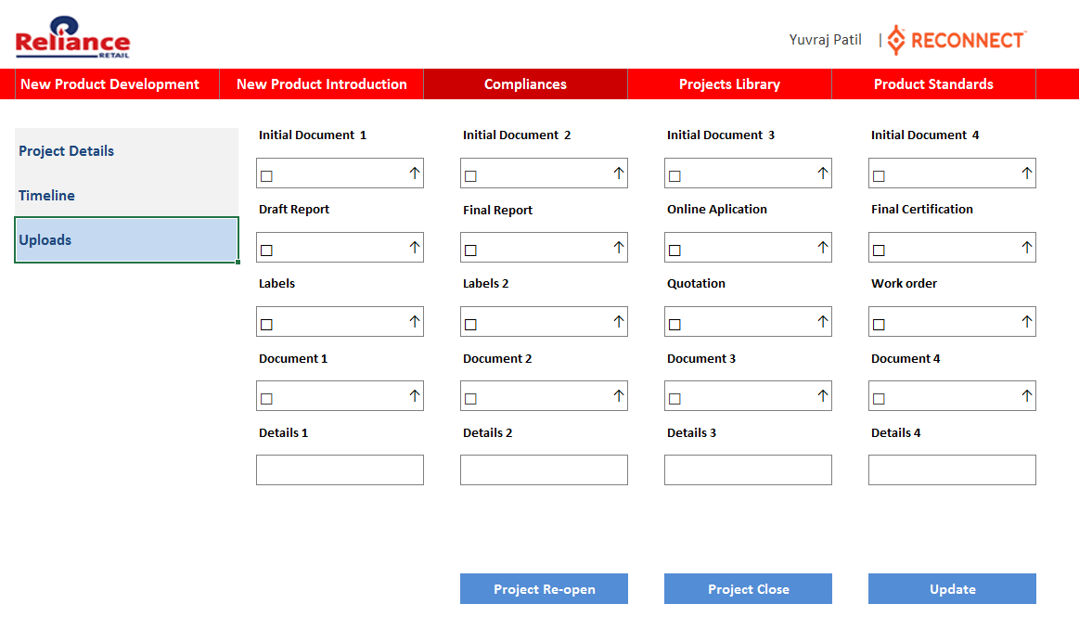
Documents uploads : □ | Input Data : Check box : Check Box tick ON + click on update means uploaded documents by compliance is freezed & need to store | Req: If compliance user need to update freezed documents then he has to untick Check Box.
Documents uploads : ↑ | Upload Data: File upload pop up. Zip File upload
Details | Input Data : Alphanumeric Format 100 Char limit
Documents uploads : Comments | Input Data : Alphanumeric Format 100 Char limit
Documents upload : Save | Click : Save the comments
Update | Click : Save the uploaded documents
Project Close | Click : Project request get removed from compliance dashboard , stored in library & same time get displayed in NPI dashboard completed compliance.
Project Re-Open | Click: Project will get displayed in Compliance dashboard.
Project Details | Click : Go to current Compliance BEE Details
Timeline | Click : Go to current Compliance BEE Timeline
Uploads | Click : Go to current Compliance BEE Uploads

WPC: Details: Product Details
Request Type | Auto Data : From submitted Request by NPD Project Details
Requester | Auto Data : From submitted Request by NPD Project Details
Request To | Auto Data : From submitted Request by NPD Project Details
Project start Date | Auto Data : From submitted Request by NPD Project Details
Required PRN Date | Auto Data : From submitted Request by NPD Project Details
PO Qty | Auto Data : From submitted Request by NPD Project Details
Priority | Auto Data : From submitted Request by NPD Project Details
Brand | Auto Data : From submitted Request by NPD Project Details
Sub Brand | Auto Data : From submitted Request by NPD Project Details
Product segment | Auto Data : From submitted Request by NPD Project Details
Product Family | Auto Data : From submitted Request by NPD Project Details
Product class | Auto Data : From submitted Request by NPD Project Details
Product Brick | Auto Data : From submitted Request by NPD Project Details
Article Description | Auto Data : From submitted Request by NPD Project Details
Reliance Model No | Auto Data : From submitted Request by NPD Project Details
Vendor Model No | Auto Data : From submitted Request by NPD Project Details
Vendor | Auto Data : From submitted Request by NPD Project Details
Factory Audit | Auto Data : From submitted Request by NPD Project Details
Serial Number | Auto Data : From submitted Request by NPD Project Details
Mandatory Compliance | Auto Data : From submitted Request by NPD Project Details
Remark | Auto Data : From submitted Request by NPD Project Details
Update | Auto Data : From submitted Request by NPD Project Details
Project Details | Click : Go to current Compliance WPC Details
Timeline | Click : Go to current Compliance WPC Timeline
Uploads | Click : Go to current Compliance WPC Uploads

WPC: Details: Timeline
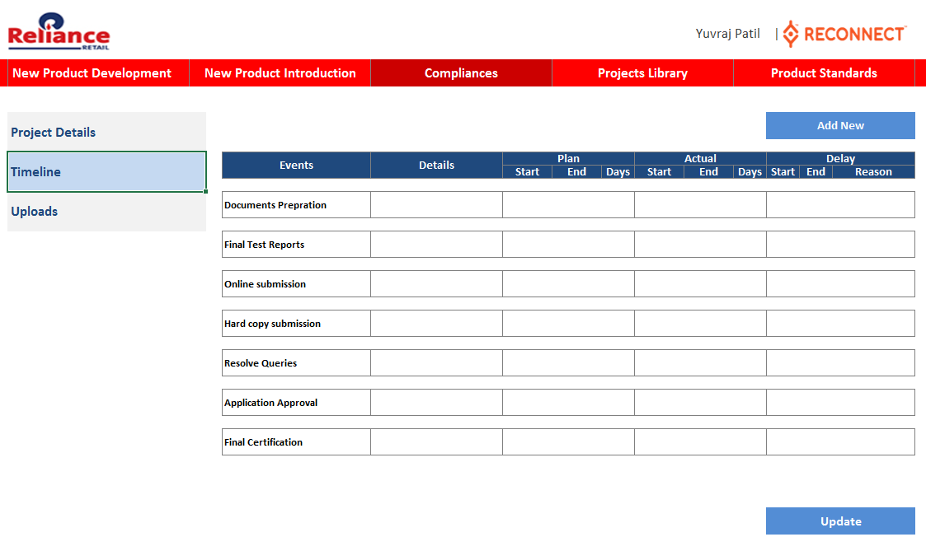
Add New | Click: Add single blank Row at bottom of timeline table
Events | Req: By default all events are mandatory in every timeline. User may add new Row for another events but cannot delete by default events. | Input Data : Alphanumeric Format 50 Char limit
Details | Input Data : Alphanumeric Format 100 Char limit
Plan Start , End | Input Data: Choose: calendar view to choose dates. 10/10/2018 & Numeric Format , 10 Char limit
Plan Days | Auto Data: (Plan End – Plan Start), Values in number format.
Actual Start | Input Data: Choose: calendar view to choose dates. 10/10/2018 & Numeric Format , 10 Char limit
Actual End | Auto & Input Data: Once user mentioned start date, Automatically today’s date should come till user manually select date.
Actual Days | Auto Data: (Actual End – Actual Start), Values in number format.
Delay Start | Auto Data: (Plan start – Actual Start), Values in number format
Delay End | Auto Data: (Plan End – Actual End ), Values in number format
Reasons | Input Data : Alphanumeric Format 100 Char limit
Update | Click : Save all new updates
Project Details | Click : Go to current Compliance WPC Details
Timeline | Click : Go to current Compliance WPC Timeline
Uploads | Click : Go to current Compliance WPC Uploads

WPC: Details: Uploads
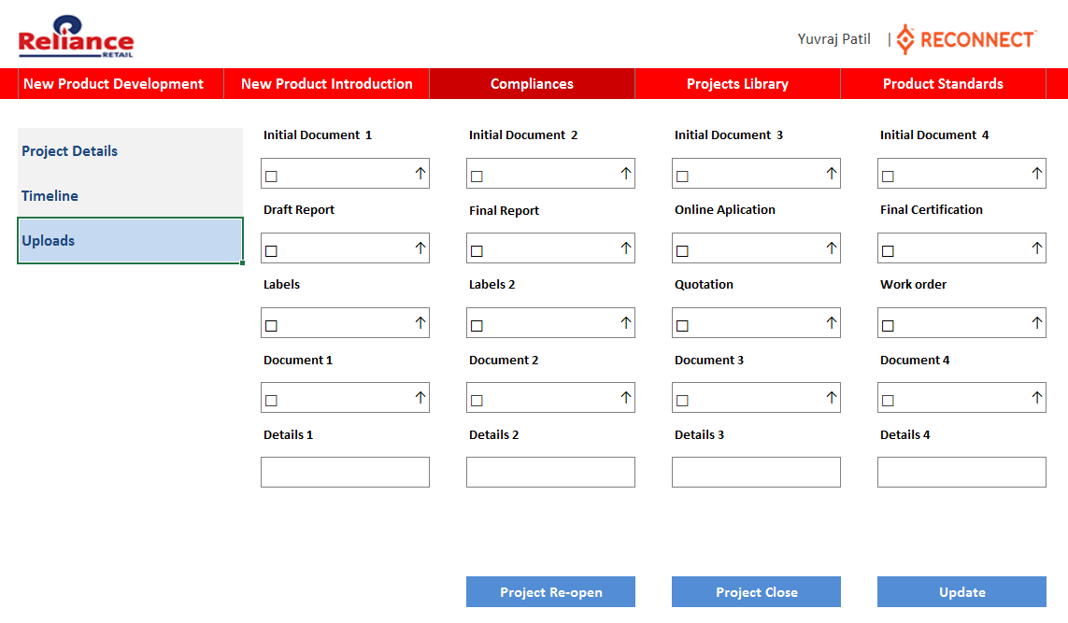
Documents uploads : □ | Input Data : Check box : Check Box tick ON + click on update means uploaded documents by compliance is freezed & need to store | Req: If compliance user need to update freezed documents then he has to untick Check Box.
Documents uploads : ↑ | Upload Data: File upload pop up. Zip File upload
Details | Input Data : Alphanumeric Format 100 Char limit
Documents uploads : Comments | Input Data : Alphanumeric Format 100 Char limit
Documents upload : Save | Click : Save the comments
Update | Click : Save the uploaded documents
Project Close | Click : Project request get removed from compliance dashboard , stored in library & same time get displayed in NPI dashboard completed compliance.
Project Re-Open | Click: Project will get displayed in Compliance dashboard.
Project Details | Click : Go to current Compliance WPC Details
Timeline | Click : Go to current Compliance WPC Timeline
Uploads | Click : Go to current Compliance WPC Uploads

USER INTERFACE REQUIREMENTS
UI Design team is working on it. Once done, we will publish the same with this document.

BUSINESS SPONSOR / BUSINESS PROJECT MANAGER / STAKEHOLDERS
Stakeholders are the individuals or groups who have a vested interest in this project and whose interests need to be considered throughout the project. This section lists the Stakeholders of the Application / Project for which these Business requirements are documented.

 | Business / Department | Names
Business Sponsor | Global Sourcing | Sanjay Nikam
Business Project Manager | Information Technology | Chandrashish Chauhan
Business POC (Point of Contact) | Sourcing-Quality, Global Sourcing | Nandkumar Patil, Yogesh Ajmera
Other Stake Holders | IT Team | Vivek Deshpande, Srinivasan Ramamurthy, Ankit Panchal, Anita Bangar, Swapnali Varak

ANNEXURE

